Assessment : sunil Tikoo

Pseudo code 10 Marks

Q1 : Write a Pseudo code for verify if number entered is prime number.

BEGIN

DECLARE tempNumber as Number

DECLARE isPrime as boolean

Get tempNumber and store them

START

Counter = 2

isPrime = true;

WHILE(tempNumber > counter) do

If(tempNumber MOD counter == 0) Then

isPrime = false;

break;

END IF

counter = counter +1

END WHILE

END

if(IsPrime == true ) Then

Display "NUMBER IS PRIME"

ELSE

Display "NUMBER IS NOT PRIME"

END IF

END

END

Q2: Write a Pseudo code for transferring amount from one account to another. [Should validate whether both accounts exists]

Q2. here i have written 2 logics

BEGIN

DECLARE debitAccount, creditAccount, amount,newCreditBalance, newDebitBalance as Number

Get debitAccount, creditAccount, amount and store them

if(CheckAccountEXISTS(debitaccount) ) THEN

if(amount < checkAccountBalance(debitAccount)) Then

newDebitBalance = checkAccountBalance(debitAccount) - amount

Display "Amount " amount " debit from account", debitAccount ," for fund transfer. Net Balance is ", newDebitBalance

if(CheckAccountEXISTS(creditAccount)) THEN

newCreditBalance = checkAccountBalance(creditAccount) + amount

Display "Amount " amount " credited to account", creditAccount ," NET BALANCE IS ", newCreditBalance

ELSE

DISPLAY "INVALID CREDIT ACCOUNT NUMBER "

newDebitBalance = checkAccountBalance(debitAccount) + amount

Display "Amount reversed back to account", debitAccount , " as credit account is invalid. Net Balance is ",newDebitBalance

END IF

ELSE

DISPLAY "INSUFFIECIENT BALANCE."

THEN

ELSE

DISPLAY "INVALID DEBIT ACCOUNT NUMBER "

END IF

END

BEGIN

DECLARE debitAccount, creditAccount, amount,newCreditBalance, newDebitBalance as Number

Get debitAccount, creditAccount, amount and store them

if(CheckAccountEXISTS(debitaccount) ) THEN

if(CheckAccountEXISTS(creditAccount)) THEN

if(amount < checkAccountBalance(debitAccount)) Then

newDebitBalance = checkAccountBalance(debitAccount) - amount

newCreditBalance = checkAccountBalance(creditAccount) + amount

Display "FUNDS TRANSFERRED SUCCESSFULLY from Account", debitAccount ," to credit Account", creditAccount, "amount transferred is ", amount, "Balance in Account is"

ELSE

DISPLAY "INSUFFIECIENT BALANCE."

THEN

ELSE

DISPLAY "INVALID CREDIT ACCOUNT NUMBER "

END IF

ELSE

DISPLAY "INVALID DEBIT ACCOUNT NUMBER "

END IF

END

RDBMS: 30 Marks

Q1. Write SQL Query to create following tables [DO NOT CREATE PRIMARY / FOREIGN KEYS ]

Customer: CustomerId, Fullname, address, city, pan number

Account: accountNo, accType, balance, customerId

CREATE TABLE CUSTOMER (

CustomerId varchar(5),

Fullname varchar(30) ,

address varchar (50),

city varchar (20) ,

PAN_Number varchar(9)

)

CREATE TABLE ACCOUNT (

AccountNo varchar(8),

AccType varchar(10) ,

Balance NUMBER (15,2),

customerId NUMBER(5)

)

Q2. Write SQL to insert following records in Customer & Account tables:

INSERT into CUSTOMER (CustomerId,Fullname,address,city,PAN_Number) values('C1005','Ajay Deol', 'Bandra', 'Mumbai','AUIO 7676 K')

INSERT into ACCOUNT (AccountNo,AccType,Balance,customerId) values('SB166778','Current', '16000', 'C1008')

|  |  |  |  |  |
| --- | --- | --- | --- | --- |
| C1002 | Rajiv Bhatia | Xyz Path, Chandni chowk | Delhi | AXNSS 1234 A |
| C1003 | Alia Bhatt | Khar | Mumbai | SZAXS 5656 B |
| C1004 | Vijay Deol | Bandra | Mumbai | APOI 5675 A |
| C1005 | Ajay Deol | Bandra | Mumbai | AUIO 7676 K |

|  |  |  |  |
| --- | --- | --- | --- |
| - | Savings | 67000 | C1002 |
| CB565556 | Current | 786928.98 | C1002 |
| SB876565 | Savings | 547899.90 | C1004 |
| SB565722 | Savings | 67600 | C1003 |
| SB757676 | Savings | 66197.88 | C1003 |
| SB166778 | Current | 16000 | C1008 |

Q3. Write a Left Join to get all customers and accounts. Join should display all customers [Even those who DO NOT have any account].

SELECT * from CUSTOMER left join account using(CUSTOMERID)

UML 10 Marks

Q1. For RDBMS Question #1, Create Class Diagram for Both tables.

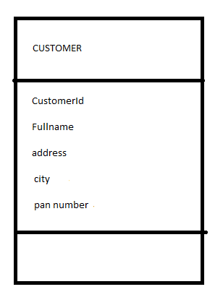

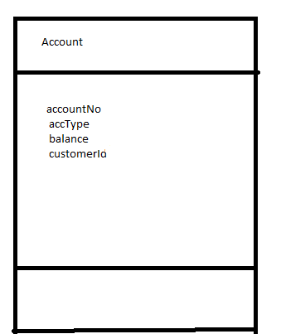

Q2. Create an Activity Diagram to explain fund transfer.

HINT: Fund transfer is possible from Any account type to any other account type.

Must validate existence of both account

Must validate account balance before transfer

Must update balance after transaction completes.

